**Issuer: Dinesh Mohan**

**Reviewer: Carolyn Ahrens**

**Date: 2017-04-03**

**Issue: V1.0**

**Order IT - One Time Delivery**

Global DC Instructions

Table of Contents

Contents

1. Document Overview 3

1.1. Roles and Responsibilities 3

2. Request Phase 5

2.1. Analyzing a request 5

2.2. Assigning a DC 5

2.3. House Keeping Activities 6

2.4. Analyze Request: 6

2.5. Creating Analyze Subtask 6

2.6. Dispatcher subtask team Actions: (FYI for DC) 8

2.7. Kickoff Meeting 8

2.8. Reclassification in OrderIT after Kick-off Meeting 8

3. Proposal Phase 10

3.1. Creating Proposal Sub-Task 10

3.2. Creating Proposal entry 12

4. Delivery Phase (Direct Order begins here) 13

4.1. Analyze Subtasks 13

4.2. Creating Delivery Subtasks 14

5. Confirming the Delivery 17

5.1. Entering Agreed Delivery Date 17

5.2. Handling deviations 17

6. Follow Up Phase 19

6.1. Post Approval Activity 20

# Document Overview

This Global Service Delivery Working instruction Document provides working instruction on how a Delivery Coordinator should handle a new request or delivery. It briefs the procedure on how a DC should handle the Job in each IDP (Infrastructure Delivery Process) Phases.

The following activities are required to be done during coordination of an Order IT job (Request Special Services or Direct Order)

This document can be used as an initial introduction to new DC’s. Order IT’s main task is to formalize communication between the requester and DC during the delivery process.

## Roles and Responsibilities

Orderer/Requester

An Orderer / Requester are the initiator of the request in Order IT. She/he is financially responsible for placing the Order in Order IT and will be recipient of the delivery information from the DC. An Order could be any of the following

Delivery Manager (DM) or Business Solution Lead

Business Infrastructure Manager (BIM)

Project Manager

Volvo IOS Onsite Manager

Other authorized Volvo Requestor

Delivery Coordinator

A Delivery Coordinator co-ordinate requests for infrastructure with full accountability of carrying deliveries to agreed cost, quality and time commitments.

Dispatcher

The role of a dispatcher includes analyze and classify new requests in Order IT, dispatching to correct Delivery Co-coordinator, addressing complex requests to the dispatch team and reject requests on behalf of the dispatch team in case of incorrect requests.

Dispatcher also supports delivery coordinator in technical issues.

Solution Designer

The Infrastructure technician carries out planning, maintenance, problem management, installation in test & QA environment, verify quality and functionality of infrastructure components. In general, a technician under immediate supervision works from specifications to assist with design, adaptation, benchmark testing, installation, debugging, documentation and maintenance of infrastructure components.

# Request Phase

## Analyzing a request

An incoming request shall contain certain mandatory information. The dispatcher/Pre- screening team is responsible for scrutinising it before it is assigned to a DC. The Dispatcher / Pre-screener will try to ensure that there is some basic information about the request:

* If the request requires a Proposal, then the Requestor should provide the Requestor Check List
* If it’s already identified non-standard, then the Dispatcher should inform the Requestor that an approval is required from Volvo IOS Service Management

## Assigning a DC

Dispatcher assigns a DC for the new request in Order IT. The DC and the requester are notified via an automatic mail from Order IT that a DC has been assigned.

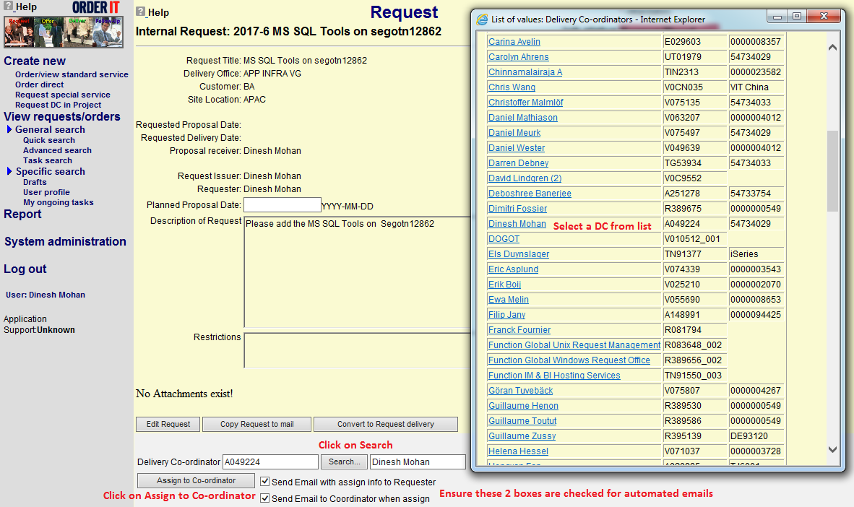

DC can find the requests in Order IT as follows:

1. Open [Order IT](http://orderit.volvo.se/)
2. Select **Login** in the left-hand menu
3. Under [**View requests/orders**](javascript:StartAction('Label_2',document.frmMenu1)) **>> General search** press **Quick search**
4. Press **Search** by the **Delivery Co-ordinator** field
5. A new window opens up **“Select Delivery Co-ordinator”**, select your name.
6. Press **Show Jobs**

## House Keeping Activities

* Below House Keeping Activities in Outlook Mailbox to be followed by all DC’s.
* Create a folder in Outlook Mailbox as Jobs
* Under Jobs create 2 folders ”Active” & ”Completed ” (If required create “Cancelled” folder to move all the emails related to the cancelled Jobs, else move the emails to completed folder)
* Under Active Create a new folder with the recently received Order IT Job number and name
* Move all incoming mails related to the job to this folder
* Under Active Folder create a subfolder with the new Order IT number & name.
* Naming convention should be “Job no : Job Title:”  
  Ex: 2017- 6 MS SQL Tools on segotn12862

## Analyze Request:

Understanding the request:

* Read all information and documents in the job
* Speak with Orderer/Issuer and any individuals referenced in the text of the OrderIT to completely understand the requirement
* Consult technical teams to understand any prerequisites and deliverables.
* If the request is classified as Advanced or Complex, it is mandatory to call for a Kick Off meeting with technical teams, requestor and customer if needed). Else optional.

## Creating Analyze Subtask

* Send subtask and ask for a resource (AXX)
* Expected lead-time 2 days to get a reply off whom to call for a Kick off meeting.
* Describe the request

**Naming Convention for Analyze Subtask:**

*An Example:*

*AO3: WINDOWS: Kickoff Meeting*

*Specification:*

*“Hi Team,*

*Please provide a resource to attend the kickoff Meeting.*

*Thanks*

*DC Name”*

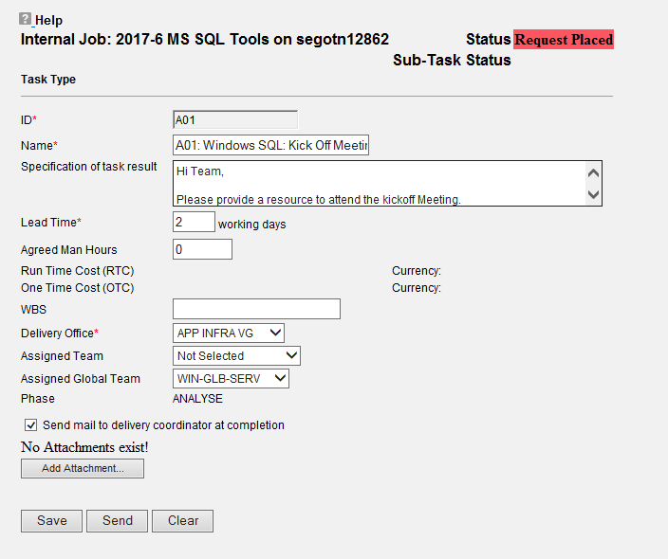

## Dispatcher subtask team Actions: (FYI for DC)

* Assign a Solution Designer who can attend a Kick Off meeting
* Save and Complete the (AXX) task at the same time that the resource is assigned (within 2 days)
* The DC will receive a mail with info about the assigned Solution Designer and can then call him/her to the Kick off meeting.
* Note! When the dispatcher close the tasks, you will receive an additional mail with the dispatchers name, but it’s the person who was first assigned and that is also named in the comment you should call for a Kick Off meeting

## Kickoff Meeting

* Plan and schedule appointed Solutions Designers to attend the Kick Off meeting,
* Analyze the request together with Solutions Designers
* Get an overall picture of how to proceed and what solution the Proposal will be based on
* Take notes from the Kick Off meeting ( to be attached in Proposal tasks)
* Send appropriate Order Forms to the Customer. (when you know it'll be a part of proposal) or discuss them at the meeting if the customer representative is attending
* Based on analysis, change job classification (Normal, Advanced, Complex) if needed.
* Make a summary of the job including conclusions and send a communication to the parties involved.

Key Points to Remember:

* It’s mandatory to perform Kick Off meetings in the request phase if the request is classified as Advanced or Complex (agreed with global request teams according to Request Handling Framework)

## Reclassification in OrderIT after Kick-off Meeting

Status ‘Request Confirmed’ indicates that the DC has a clear understanding of all the business requirements for the request.

When ***Confirming Request*** the DC is to secure that the request is correctly classified in Order IT. There are three different classes:

* **Normal** (called MS STD.NORMAL in Order IT); for requests comprising delivery of one or two standard components (products and/or services).
* **Advanced** (called MS STD.ADVANCED in Order IT); for requests comprising 3-10 standard components.
* **Complex** (called MS STD.COMPLEX in Order IT); for requests comprising more than 10 standard components, delivery to new customers, delivery of non-standard components or requests for global multi-site delivery.

Should a request be assigned incorrect classification, it is to be updated under **General Info** in Order IT.

NOTE:

* Preliminary delivery date of the order should be updated in Order IT post kick off meeting ONLY when DC is confident with the suggested suggestion, change the status of the Job on Order IT to "CONFIRM REQUEST**”**

# Proposal Phase

* Before proceeding, check that all necessary information and order forms are filled and available.
* Always read the instructions for the products so you know what requirements the technical teams have. Here is the [link](https://teamplace.volvo.com/sites/giosd/default.aspx) to Instructions team place.
* Create Proposal sub-tasks and send to respective technical teams

## Creating Proposal Sub-Task

* Start the naming convention of the proposal subtask as PXX

**Standard Text in Specification of Task Result:**

**An Example:**

*Overview of related sub tasks*

*P01, V1 – Windows- Proposal*

*P02, V1- Integration - Proposal*

* Lead-time: Standard - 4 work days for Normal and Advanced deliveries, unless if something else is agreed on the Kick Off meeting or stated in the instructions
* Assign it to the correct local/global team
* Include all attachments. (Kickoff meeting minutes, Order forms and other relevant documents)
* Click ‘SEND’

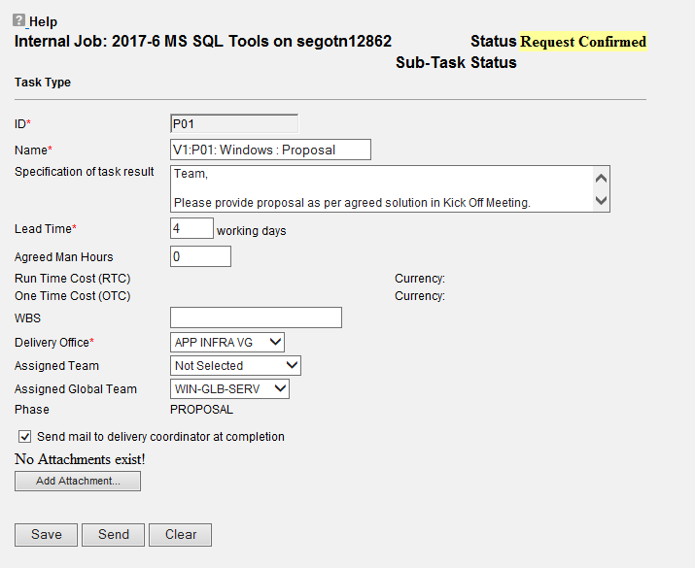

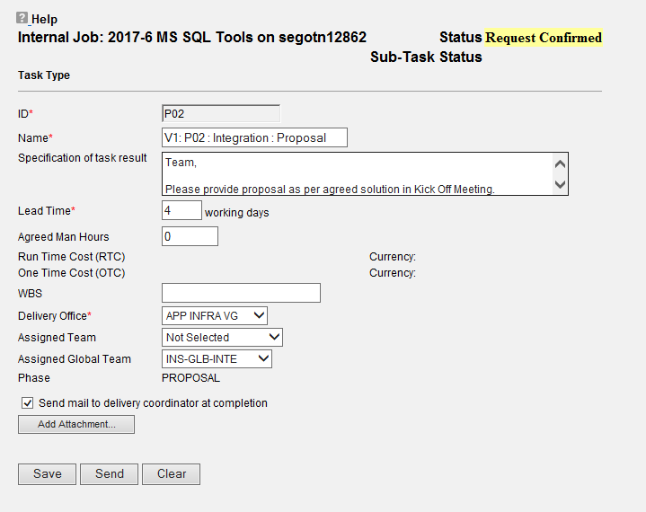

NOTE: Always use Create/Send Subtask button when you want to do changes or to do an update in the specification field on the existing sub-task otherwise the assigned technician won’t get a mail

## Creating Proposal entry

Please refer to the screenshot below on how to send proposal through Order IT, Most of the Fields are filled in automatically in this section.

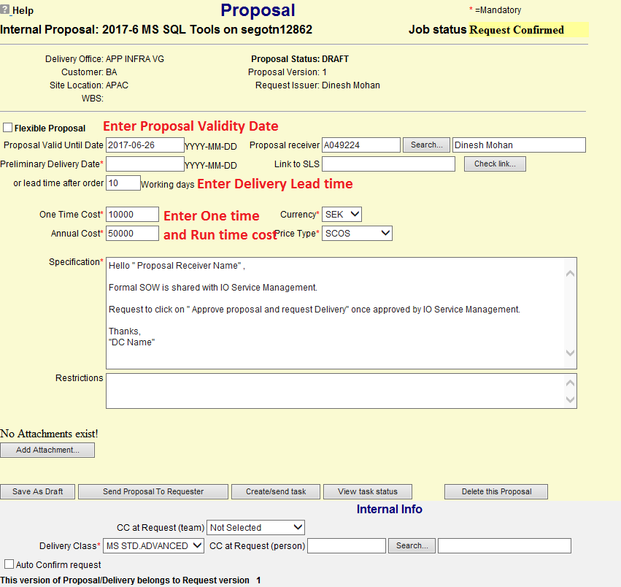

Note: Proposal Valid date will be 60 business days. Please count as per working days and update in Proposal Valid until date field. If the Proposal expires before the order is placed, then normally Volvo is required to make a new OrderIT for a new Proposal.

# Delivery Phase (Direct Order begins here)

## Analyze Subtasks

* Perform kick off meetings in delivery phase if you find it necessary in order to secure scope and requirements for an order. It’s not mandatory as we have no agreement with global request teams
* A-tasks (analyze task) in the delivery phase must be sent BEFORE confirming order.
* Analyze subtasks can be done both for Direct Orders as well as for normal requests (Optional, If DC estimates that a delivery kickoff Meeting or discussion is required)
* It is possible to send D-tasks (delivery tasks) AFTER Order Confirm and BEFORE Create Approval
* More detailed information about A-tasks you find in section 2.5 Creating Analyze Sub-task
* A-subtasks should only be used in Delivery phase for Direct Orders. If a Proposal was created for the request, then Analyze should be skipped in the Delivery Phase since the work was already done prior to making the Proposal.

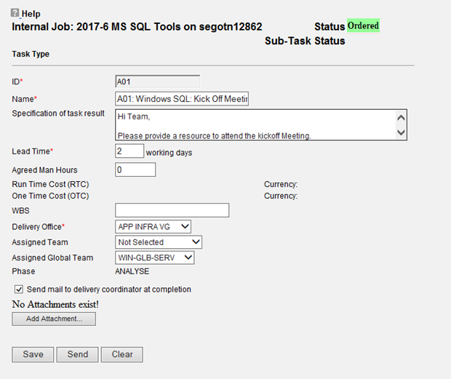

Note: ONLY when the DC is confident that all prerequisites have been met click on the CONFIRM ORDER button.

Often is it like this that the customer does not have the answer for the order forms information, and then we usually invite both the customer, Application Operation Professional, Architect or/and Solution Designer to the kick off meeting, and have a discussion for how the solution shall been set up.

For complex deliveries we usually perform several meeting before the solution and the order form is finalized.

## Creating Delivery Subtasks

* Before proceeding, check that all necessary information and order forms are filled and available.
* Always read the instructions for the products so you know what requirements the technical teams have
* Create Delivery sub-tasks and send to respective technical teams

**Name of the Delivery subtask should be in the format -**

D01**:** Windows: SQL server

D02: Integration**:** VCOM

**Standard Text in Specification of Task Result:**

* Short Information of what to do
* Expected Result
* Information about all teams Involved
* Updated Order form

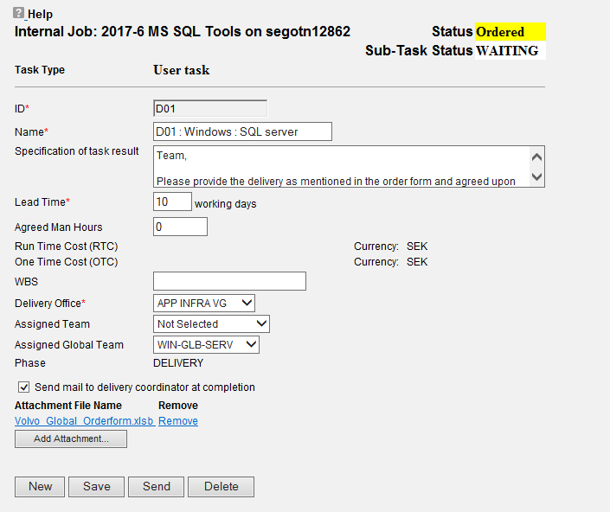

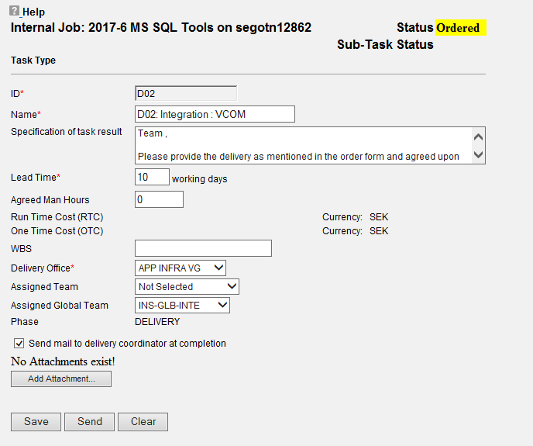

**Key points to note when sending the updated Order form:**

* When ordering something from the technical teams, all mandatory fields have to be completed. If you have problem to complete the order form, feel free to send a meeting request to the solution designer assigned to your Order IT, to get help to complete it.
* When ordering extra hardware to a server you need to enter the assignment code. It is not enough to refer to the assignment code used for the server. The technical team needs it if they ordering HW from other team and also to be used as a quality check so that correct assignment code is used.

# Confirming the Delivery

## Entering Agreed Delivery Date

* Agreed Delivery Date for the delivery should be updated in Order IT within 2 days after sending a Delivery Subtask. If the order was prefaced by a Proposal, then the Agreed Delivery Date must match the SOW that was agreed by Volvo.
* The Agreed Delivery Date should include preparation time for the D subtasks, the lead times for the D subtasks and approximately two weeks for Volvo to perform validation tests after the Delivery is complete.

## Handling deviations

* DC should carefully calculate the Agreed Delivery Date according to section 5.1 above. In case of deviations:
  + If the order was prefaced by a Proposal, then the Agreed Delivery Date can only be changed in situations where the following is true:
    - Volvo has requested any change to time or scope that has changed the Agreed Delivery Date. This must be supplemented by a documented Change Request.
    - DC has documented Volvo or third-party requirements into the SOW that were not fulfilled
    - DC has documented specific risks or assumptions into the SOW that have occurred
  + If the order is a Direct Order, then the Agreed Delivery Date can be changed in situations where the following is true:
    - Volvo has requested any change to time or scope that has changed the Agreed Delivery Date. This must be supplemented by a documented Change Request.

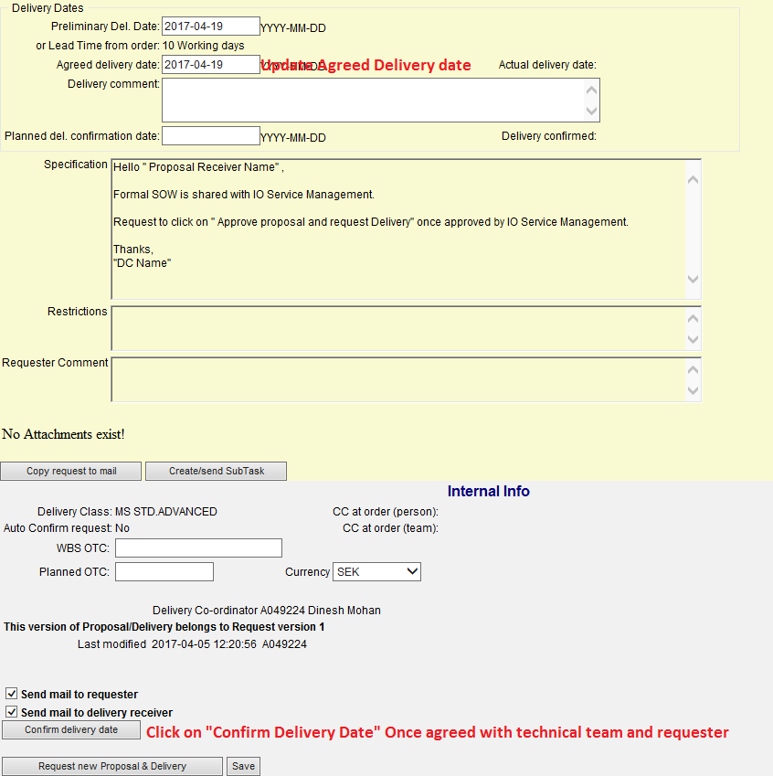

# Follow Up Phase

* Before sending the approval, confirm with the orderer that the request is completed.
* If you don’t get replies after 2 reminders, send a mail to Orderer that you are now closing the request after 3 reminders without answer.
* Send approval with actual delivery date when the last delivery activity was completed.
* Days until Auto approval – Provide 10 days for approval, if it not approved within 10days the delivery gets Auto approved.
* Remember to put your email address in the receipt receiver email address.

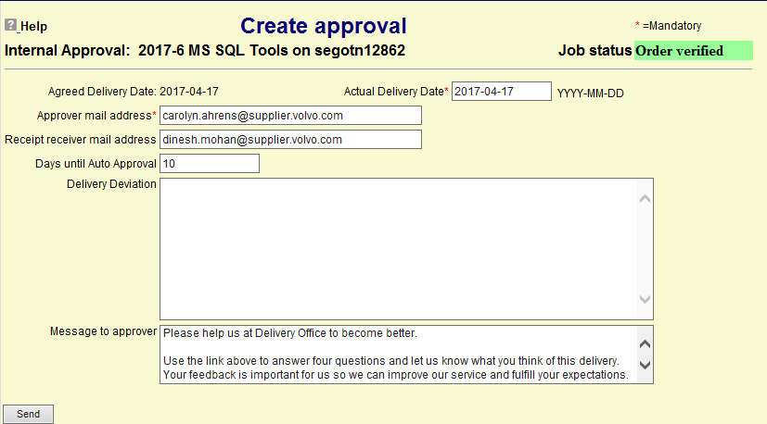

Message to approver section:

As the survey link is available for all delivery office sites when we send approval, the below text can be added in the Message to approver section before we send for approval.

”*Please help us at Delivery Office to become better.*

*Use the link above to answer four questions and let us know what you think of this delivery. Your feedback is important for us so we can improve our service and fulfill your expectations.*

*Thank you!”*

## Post Approval Activity

* Move all job sub-folders to ‘Completed’ folder in the mailbox